**Lab – Story Points**

Shaun Pritchard

Rasmussen College

QMB3300

Jerome Olorunmaiye

June 04, 2020

**Lab – Story Points**

First class high priority for November of 2015 = **129,266**.

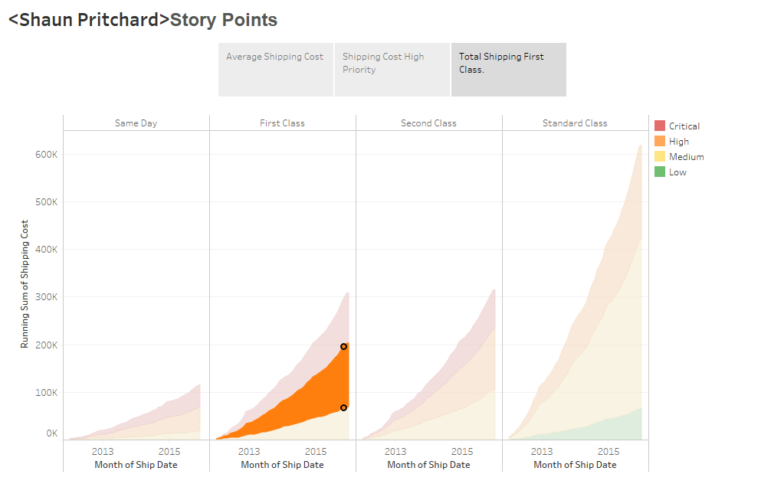

**Story Points:**

* Average shipping cost by country
* Shipping cost (high priority)
* Total shipping(first class high priority)

**Average shipping cost by country**

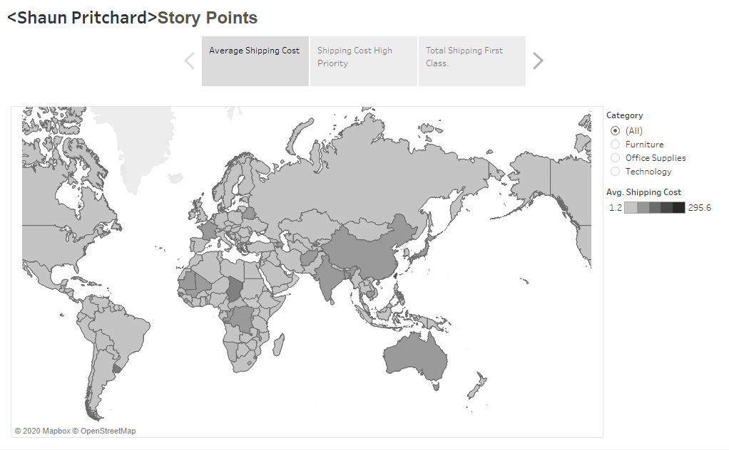

**Shipping cost (high priority)**

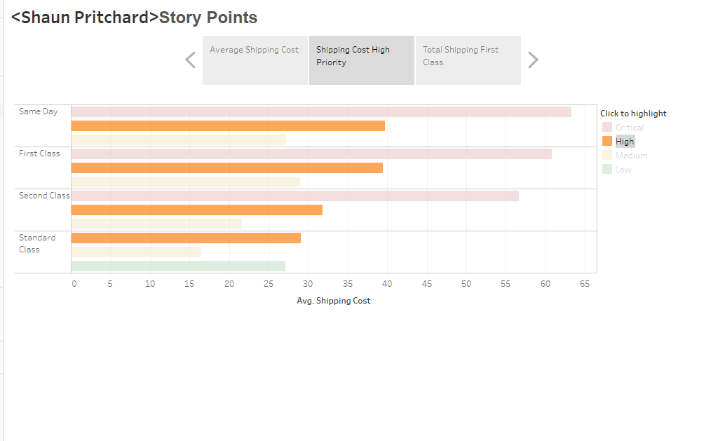

**Total shipping(first class high priority)**

